*3-Level Structure Chart*

*Ethan Dunzer*

*05/29/2021*

**Introduction**

The APC system that has been created thus far has been designed around the idea that the users will interact with the many systems through their desktop computers. This means that all interaction will take place through some application that is on the desktop computer. To summarize there are these main systems that will have user interaction: Inventory Tracking, Finance Tracking, Manuscript System, Contract System, Marketing Portfolios, Publishing System. These systems will allow the APC employees to completed predefined process in the workplace and solve identified problems.

This document is put together in order to give the technical employees at APC a useful tool for describing the high-level code components that are involved in the new APC system. This is done through the creation of a structure chart that will show the components of the manuscript element of the system. Information about said structure chart will be detailed in the analysis section which gives details about all the elements/modules.

The purpose of this assignment in particular is to take the previous information that has been created for this class for APC and input it into a structural chart format. As stated above this was done by taking information about the manuscript system in particular and creating the visual structure chart.

**Analysis**

In this section I will go over the details of the structure chart and how it works in its entirety. First though this structure chart was designed based off of the HCI diagram and documents that were created to show user interaction through the manuscript system. This means that there will only be one diagram represented here instead of all 6 different parts of the new APC to-be system. Despite there only being one part of the new system represented the principles and even tasks are very similar to other parts of the new system. The manuscript system is the most important part of the new system so it will be the only one represented.

As far as the actual chart goes the components are referred to as modules which will represent different components in the system. Each module of the chart is shown in a level format from top to bottom. Level 1 being at the top and level 3 at the bottom. Then there are the subroutines of the system which live under each module. These are typically after level 2 and are organized left to right as in order of occurrence. In between levels 2 and 3 you will see arrows which represent data transfer between each module. The arrows direction represents the direction of the data, and the text will explain the purpose of the transfer.

Each module has a number assigned to it which represents its connection along with what level it is on. For example, modules with a three-number system like 3.1.1 would be on level 3, modules with only two numbers would be level 2 and so on.

You will see simple line connections that connect module to module and represent the connection to the overall system parts. There is also a rhombus shape that is used to represent a two-way decision such as true or false, or yes or no. This shape is located under a module where the decision would occur.

As stated, before I created this chart based off of the HCI diagram in another document and it follows the same design elements of the manuscript system. Overall, this structure chart works to fill in the working gaps that the HCI does not give an explanation for. This means that the structure chart will detail how the system will work to function with user requests and show how they work in the following explanation.

As shown in the figure 1 graphic below the structure chart shows all the different elements of the new APC system and details the manuscript systems workings in particular. For reference the Manuscript system module would represent the user being at the home page of the manuscript system in the HCI document. After this there is a decision condition which was put in place because the manuscript system has 2 simple functions that are very different from each other.

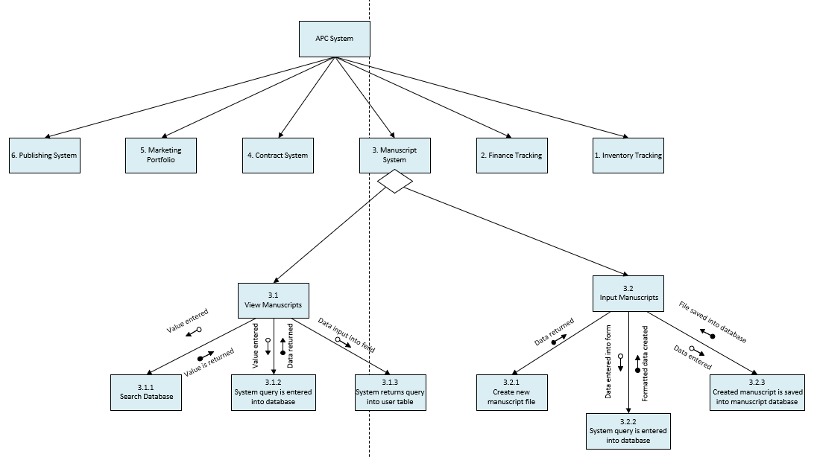

(Figure 1. APC Structure Chart)

This decision condition will determine if the user needs to access the viewing part of the manuscript system (3.1) or the input part of the manuscript system (3.2). This decision is put in place because as shown in the HCI diagram there are separate pages that the user will visit for these different modules and those are the main functions that were determined in the APC requirements.

If the user selects the search manuscripts option on the home page, they will be using the view manuscripts module (3.1) of the manuscript system. This module is shown in figure 2 below. It has 3 subs-systems that will work in order to complete the users request to the system.

First, we have 3.1.1 which details the action of a user entering a search request into the system search bar. This is taken in as a value, as shown in the diagram below as “value entered” then this value is taken and put back into the main system so that it can be passed to the next sub-system 3.1.2.

3.1.2 is in charge of taking that returned value and entering it as a query into the systems database. This is put in place to allow the data exchange between user and system. After this value is entered into the database query information from that query is returned back to the system.

Then that information is then inputted into the users table through the 3.1.3 process where that returned information is inputted into the fields required in the user interface. This then completes the users search request into the manuscript database through the manuscripts view interface.

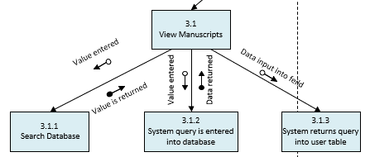

(Figure 2. APC Structure Chart Left Side)

If the user selects the Input manuscripts option on the home page, they will be using the Input Manuscripts module (3.2) of the manuscript system. This module is shown in figure 3 below. It also has 3 sub-systems that will work in order to complete the users request to the system.

3.2.1 is the first sub-system that will return data that represents a new manuscript file. This data will mostly contain backend information like time, data, a specific id, among other things but most of the data is not important to the user.

After this data is passed back to the system the data that has been entered by the user in the input form in the UI will be taken into the 3.2.2 sub-system which then formats it and returns the data back to the main system. This is important to make sure that all data is in the correct fields, categories and formats to make searching and inputting more seamless.

Then after passing that information to the main system the new formatted data will be entered into the 3.2.3 sub-system that creates a new file will all entered data. This is also important because it will take that formatted entered data along with the attached and selected files and create a single reference file that works within the system. Then that file is saved to the database by inputting it back into the manuscripts database.

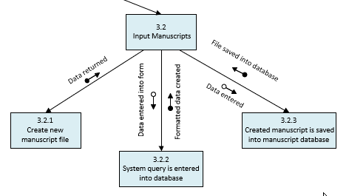

(Figure 3. APC Structure Chart Right Side)

All modules in this diagram are created in part to fulfill the APC requirements such as the ones listed in the User requirements documents. These modules shown in particular work to fulfill most of the requirements as any other module in the system. Every employee at APC has a requirement that requires access to the manuscript system and therefore makes its requirements the most important.

**Conclusion**

In this exercise I went through the many different interactions that will have taken place in the APC project models that I have created. This enabled me to really think about the user/system interactions and see potential problems and solutions that should be enabled.

This assignment was a great to plan through and detail how the user interactions will create system requirements that need to be worked out or implemented. I found this assignment to be a great way to think even more about the user interface and how each button they click will have several sub-processes and systems behind the scenes. I could definitely see how important of a document this could be to people that are maintaining or changing the system or even starting to implement it. If this document was created in full with all the different modules for the system I think it would be a much more valuable tool, then many of the other documents that we have created.